# Objective

In this tutorial, we will develop a simple Android application and use Wireless Local Area Network (WLAN) to transfer data between android device and Raspi. Through this experiment, you should master the following skills:

1. Use Android Studio develop Android application;
2. Use WLAN to communicate with android devices;
3. Know the simple grammar of Java;

# Components

1. Window PC；
2. Pad；
3. USB Type-C Cable
4. Raspi Board and Power；
5. A 16GB SD Card；
6. HDMI Screen, USB keyboard, USB mouse and HDMI Cable
7. Basic Hardware (Adapter Board, Wires, Bread Board)

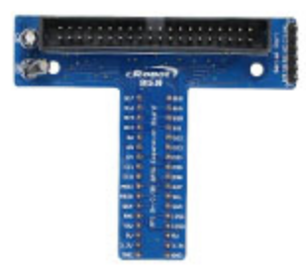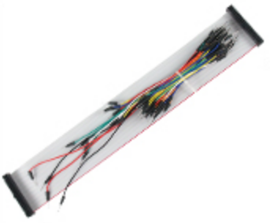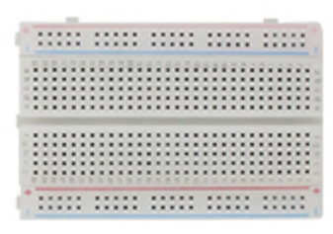

1. LCD 1602

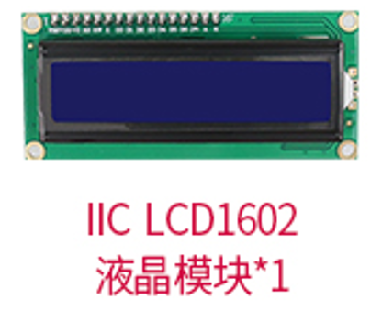

# Basic Knowledge for the Experiment

The project structure of Android studio is mainly composed of two types of files, **the program file (MainActivity.java), and the .xml file (activity_main.xml)**. The program file is mainly used for writing logic programs, and the .xml file is used to set up the graphical interface. We can do page layout in the .xml file, and then write the corresponding logic program in the .java file.

# Experimental Steps

## Hardware Connection

1. Connect LCD1602 with Raspi.



## Configure WLAN

1. Open Raspberry Pi configuration by clicking **Menu** 🡪 **Preference** 🡪 **Raspberry Pi configuration.**

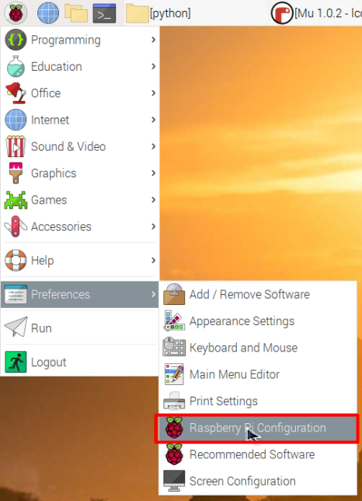

1. Change your Raspi’s name to the Device Label (i.e. **IoT-1 ~ IoT-11**) to avoid confliction with other students’ Raspi when using Bluetooth. Then click OK.

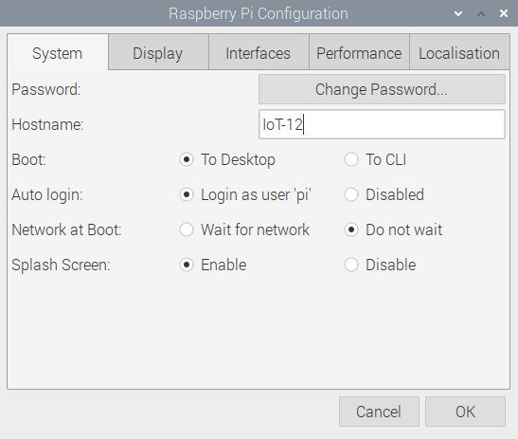

1. In the pop up dialog, click Yes to reboot Raspi.

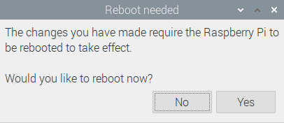

1. When Raspberry Pi OS is restarting, create an Access Point on your phone (Set your *Device Name* and *Password* and remember them. It is highly recommended that each group should create their own AP):

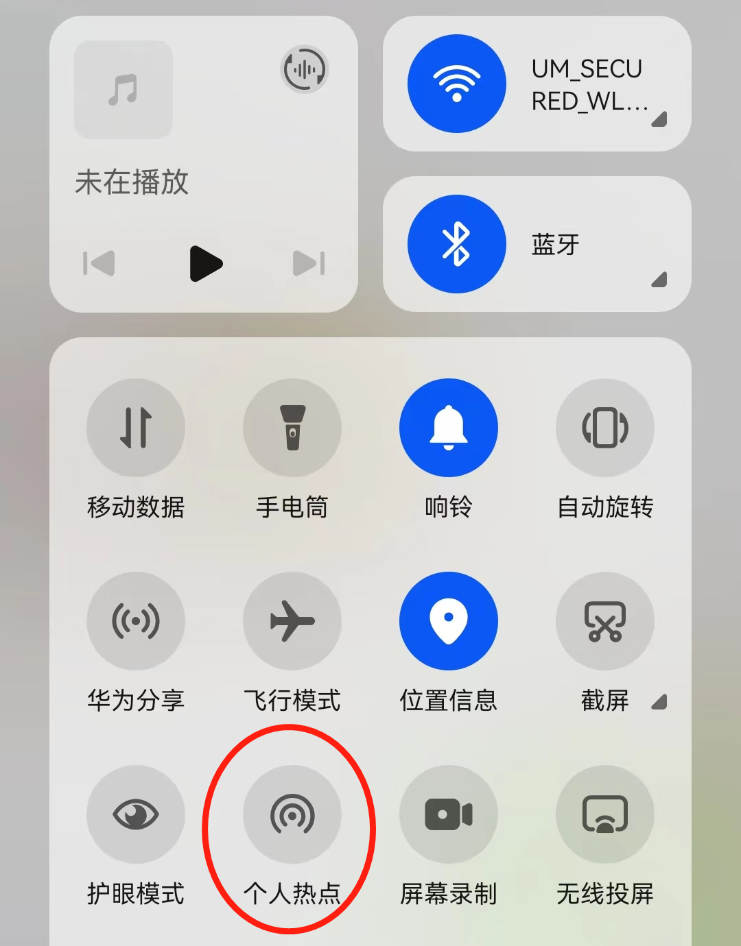

1. After Raspberry Pi OS restarts, connect the Access Point you created (Here my AP hostname is “Rainbow”).

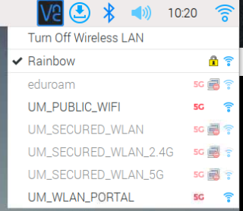

1. Build up socket communication system on raspi:

socket is a two-way communication link between two programs based on IP protocol (socket supports both TCP and UDP protocols. You can choose the protocol you want in later project.). In this tutorial, we aim to build up a UDP receiver on Raspberry Pi and a UDP transferer on Pad.

import socket

from time import sleep

s = socket.socket(socket.AF_INET, socket.SOCK_DGRAM)

raspi_ip = "192.168.43.140"#set as your raspi ip

s.settimeout(0.01)

s.bind((raspi_ip, 8003)) #raspi ip and port

print("ip", raspi_ip, "port", 8003)

def socketReceive():

    while True:

        try:

            data, addrR = s.recvfrom(128)

            datastr=data.decode(encoding='UTF-8')

            return datastr

        except:

            return False

if __name__ == '__main__':

    i=1

    while True:

        re = socketReceive()

        if re:

            print('recieved data:', re)

Notice

* Remember to replace the IP by your raspi IP

1. Use raspi terminal, type in command: ifconfig

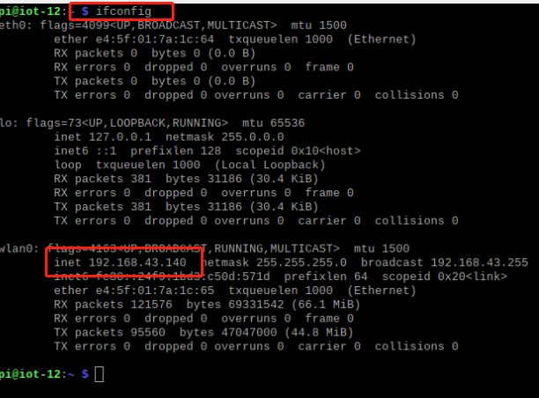

1. Find IP on your AP device (you can also find the IP of other devices that connected to your AP here):

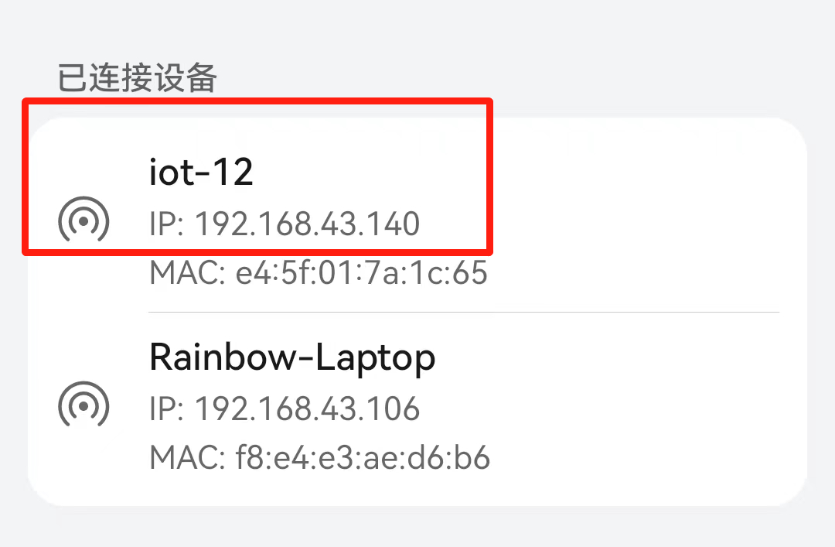

1. Check your raspi socket server:

Before we build up a transferer on Pad. It is highly recommended to check the socket server on raspi works properly or not. We can build up a transferer on raspi as well:

import socket

from time import sleep

def socketTransfer(data):

    s = socket.socket(socket.AF_INET, socket.SOCK_DGRAM)

    s.settimeout(1)

    addrT = ("192.168.43.140", 8003)#set your ip and port

    s.sendto(data.encode(), addrT)

    s.close()

if __name__ == '__main__':

    while True:

        data = str(input('input data here:'))

        socketTransfer(data)

Now, separately launch two files and run them, input the data at transferer and you can see the data transferred to receiver (transferer and receiver should be set to the same IP and Port, also, avoid using occupied Port such as 22-ssh and 80-http……).

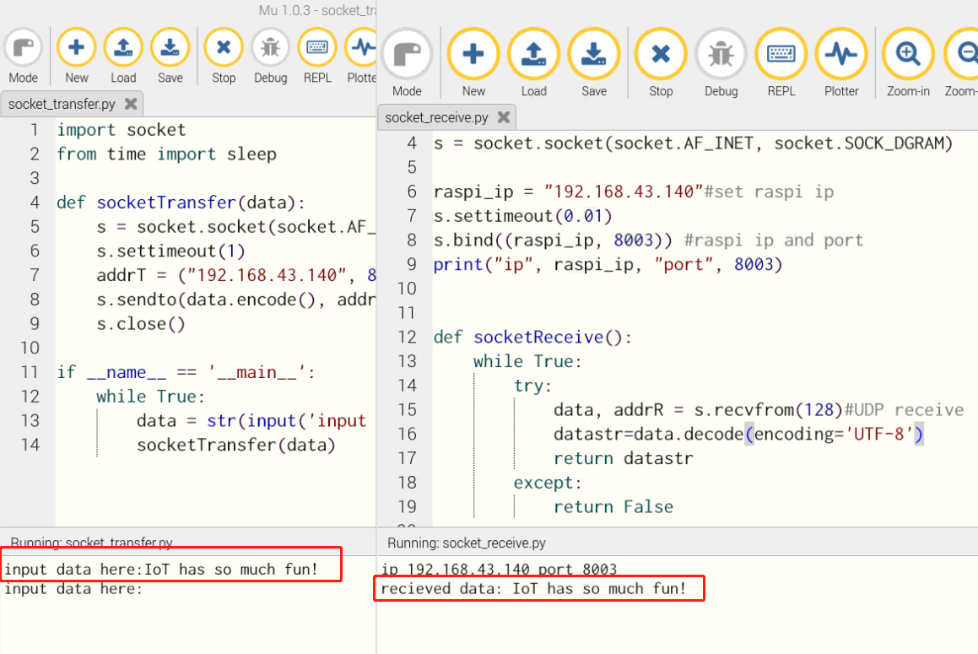

Notice

* Though we type in the same IP here. In socket UDP protocol, Transferer need the IP of Receiver. And Receiver just listen to its own IP. It explains why in Android end, we just need assign Port for Receiver.

## Design the Android Application

### Create Project

1. Open PC (You should switch your monitor to PC if you connect it with Raspi before) and start Android Studio.

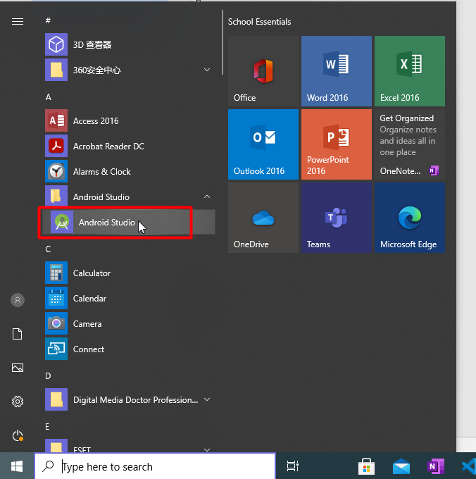

1. Create a new Android Studio project. (The version we use here is 3.5.2.)

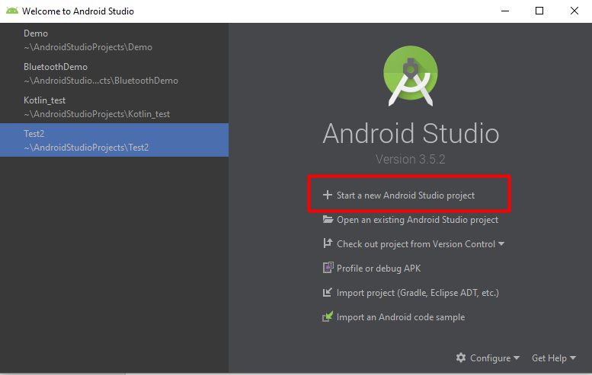

1. Select Empty Activity and press Next

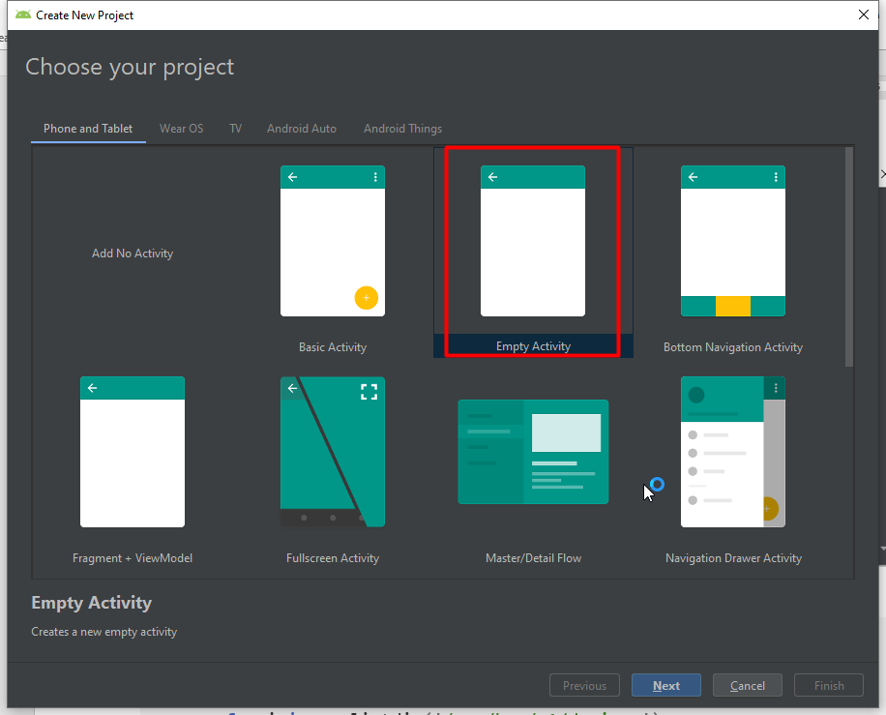

1. Give the project a name, e.g. BLE_your_name. And select Java as the program language. Then click Finish.

Notice

* If you download the newest version Android studio, it will use Kotlin by default. And you may get nothing inside when you create a new empty project. Therefore, to solve this, you need to use the former version.
* Below, two versions are given. Download from: **<https://developer.android.com/studio/archive>** Remember to set the website language to English to find the version you need.

Android Studio Dolphin | 2021.3.1 September 15, 2022

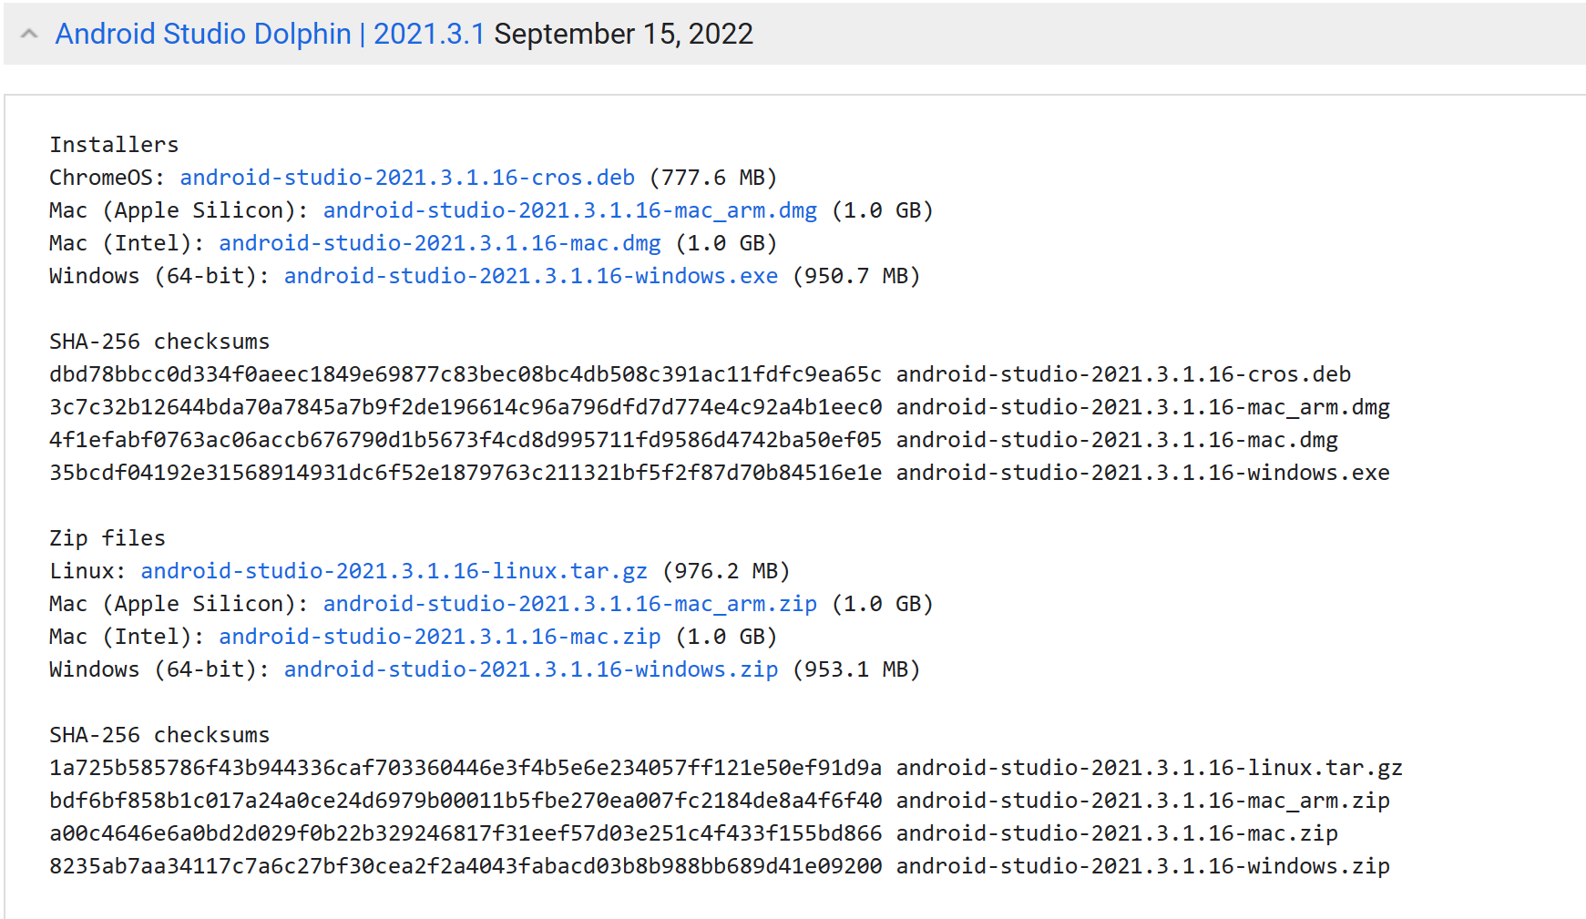

Android Studio Flamingo | 2022.2.1 Canary 1 September 20, 2022

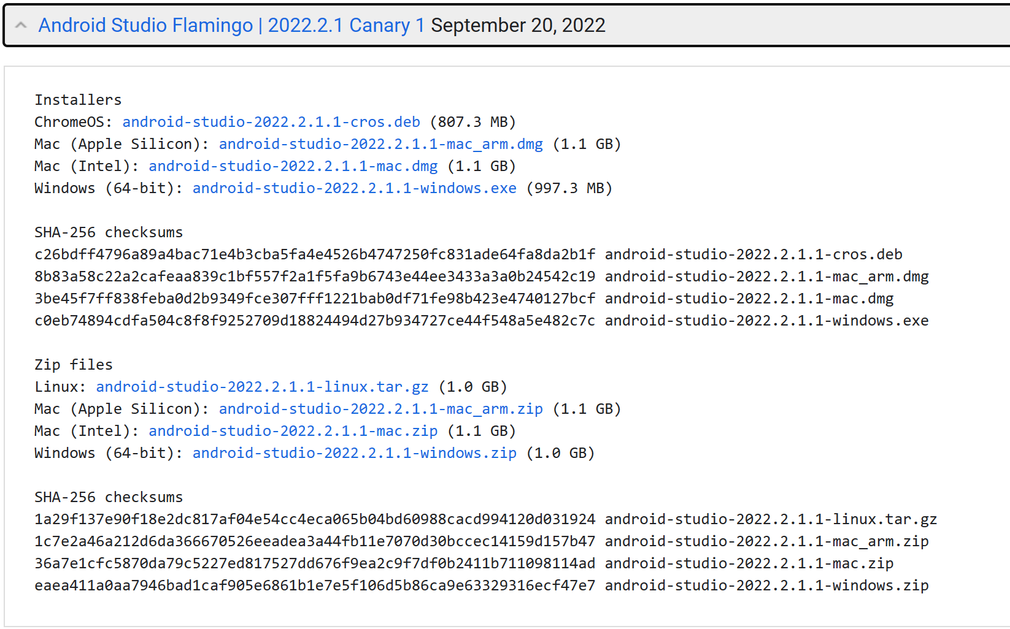

### Set User Interface (UI)

1. Open activity_main.xml file. Click the design button and further select landscape.

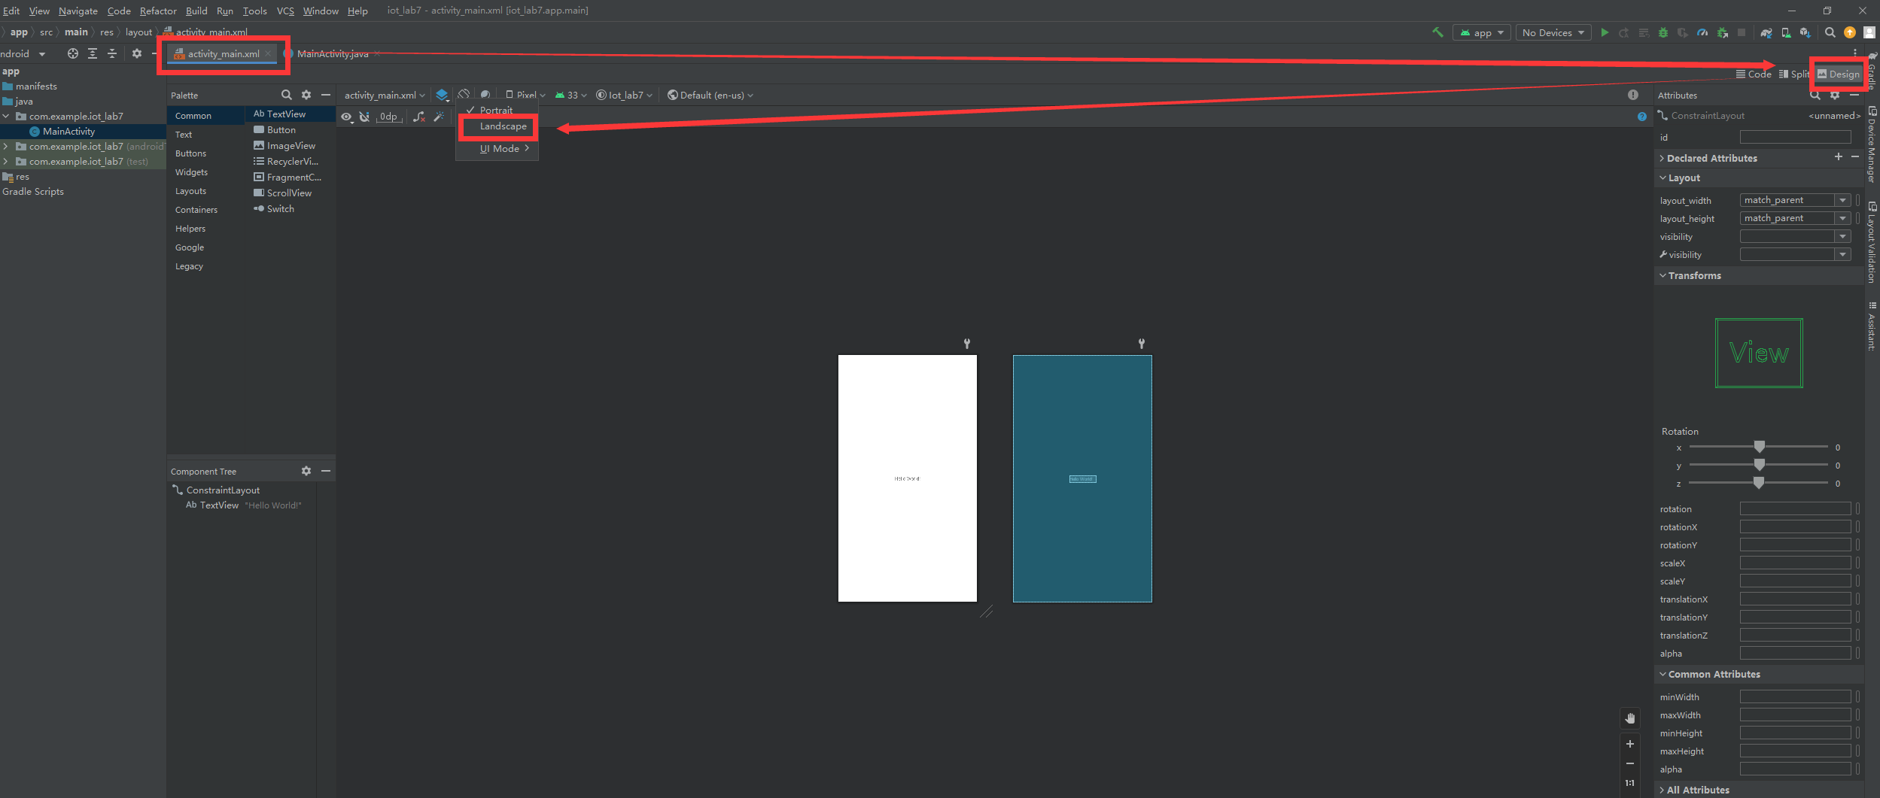

1. Select 1200x1920 pixel. We can see a white area that is the screen of our Pad, and we can design our UI on it.

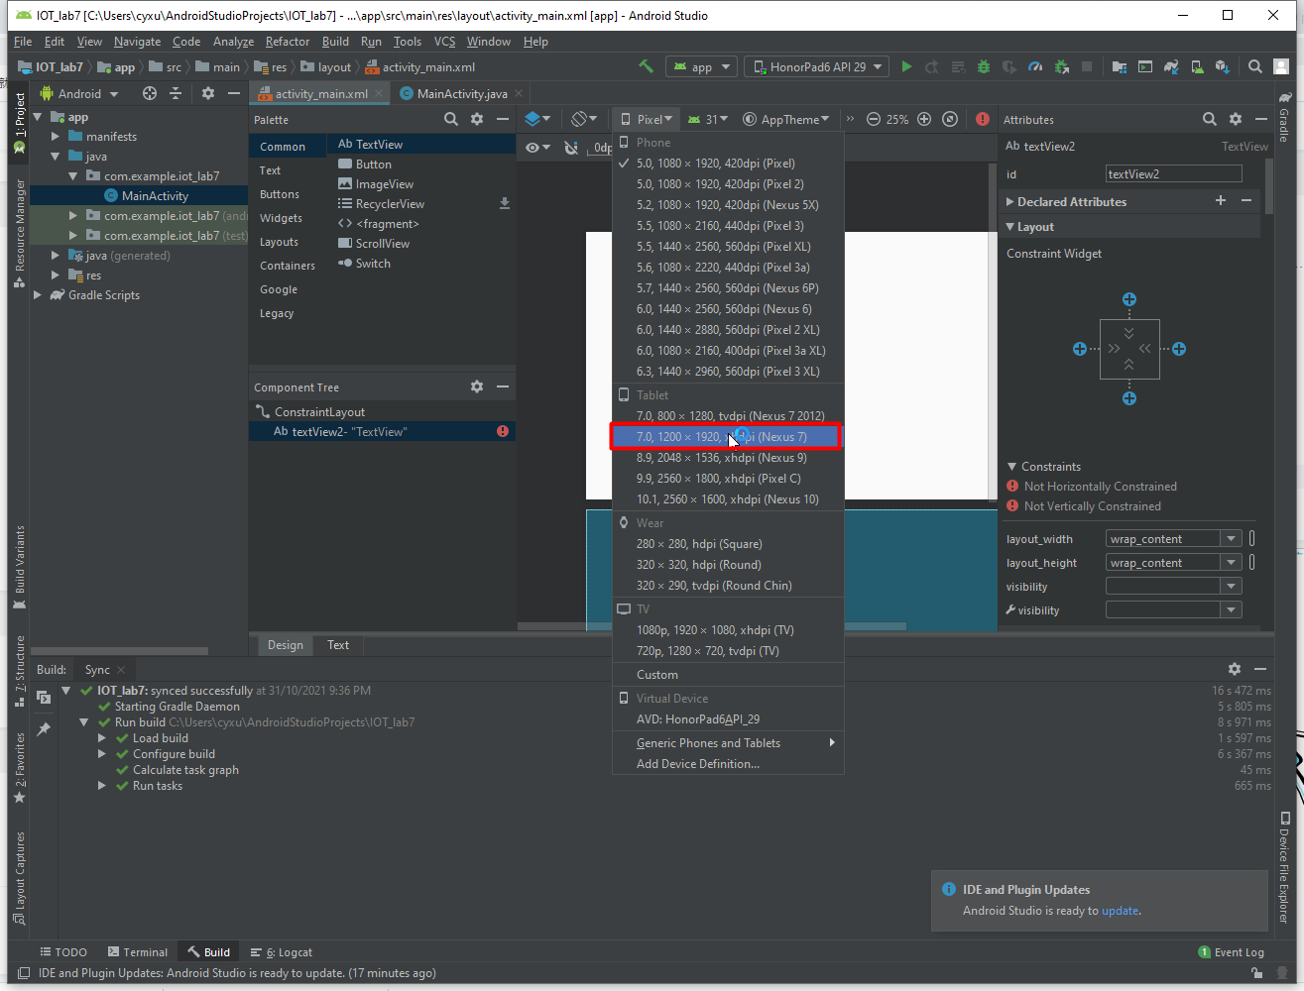

If the choice does not exist, add the device as follows.

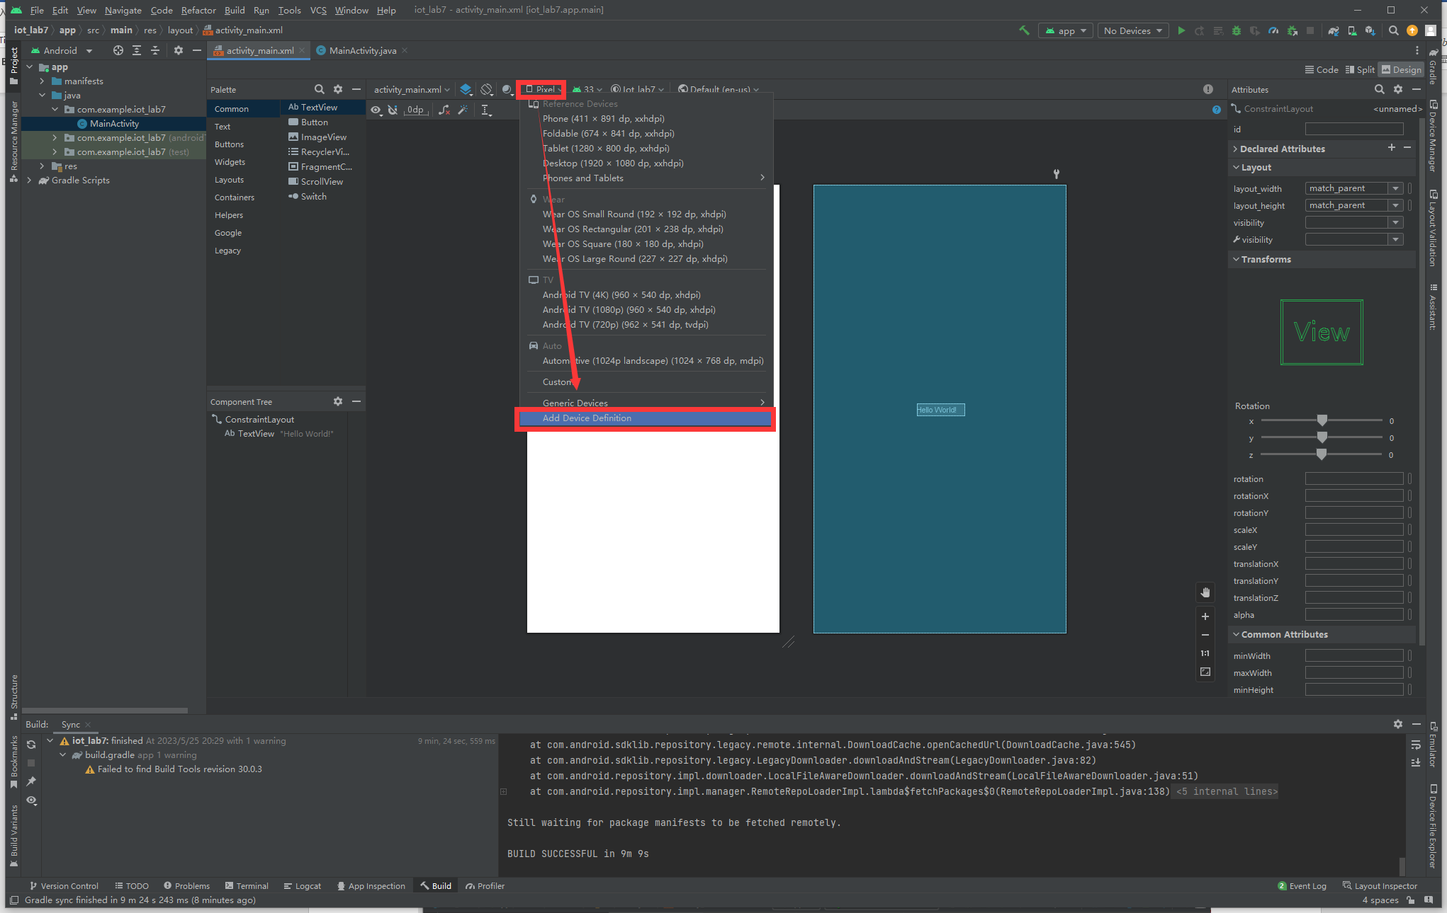

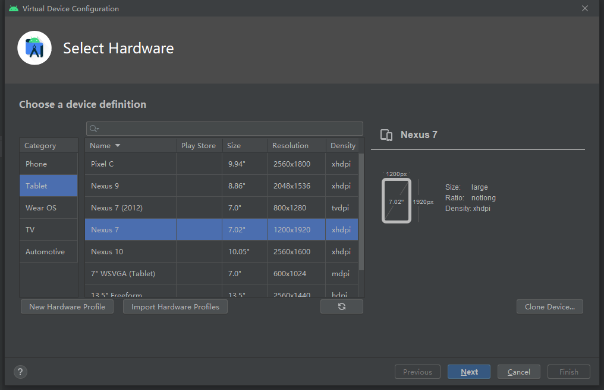

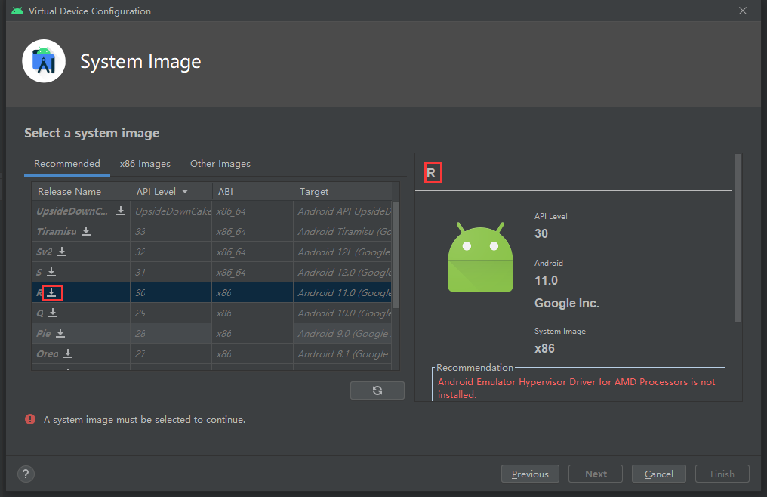

Download and install the R system image.

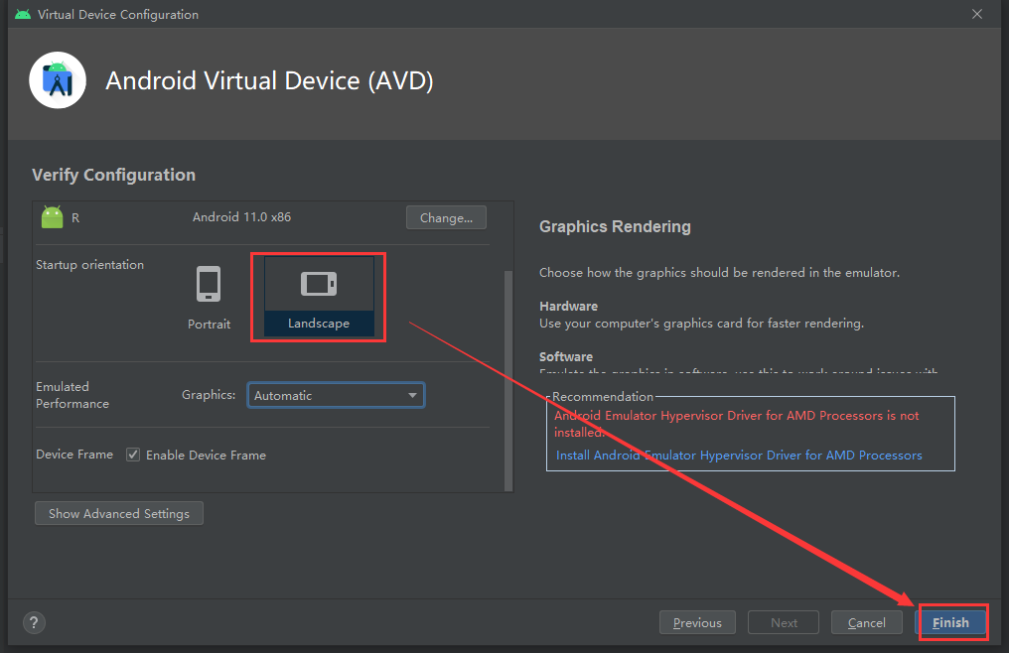

1. Add a TextView to display the sent message. The property is shown as below:

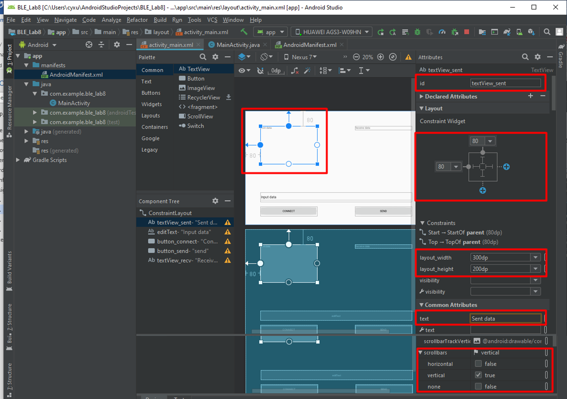

If we set the vertical scrollbar to True, a vertical scrollbar will appear when the message exceeds the region of TextView.

1. Add a TextView to display the received message. The property is shown as below:

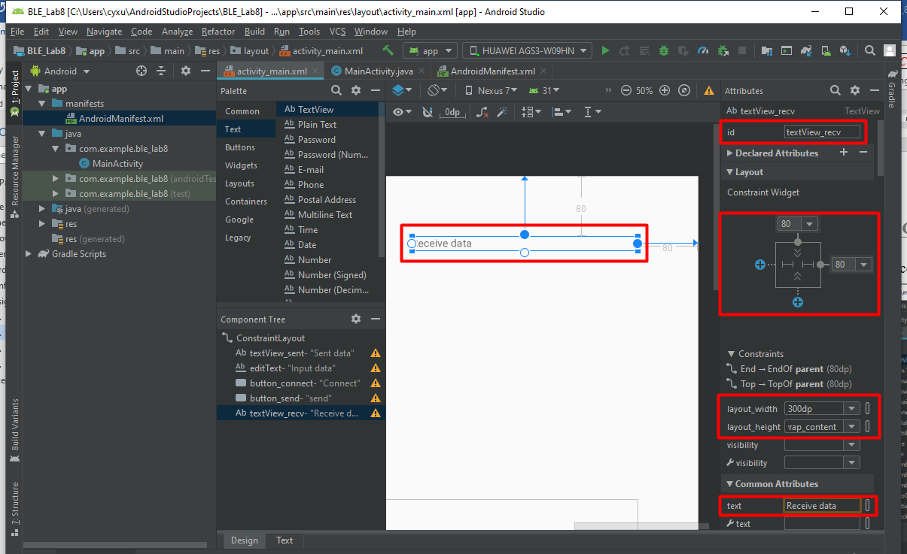

1. Add a Plain Text to input message. The property is shown as below:

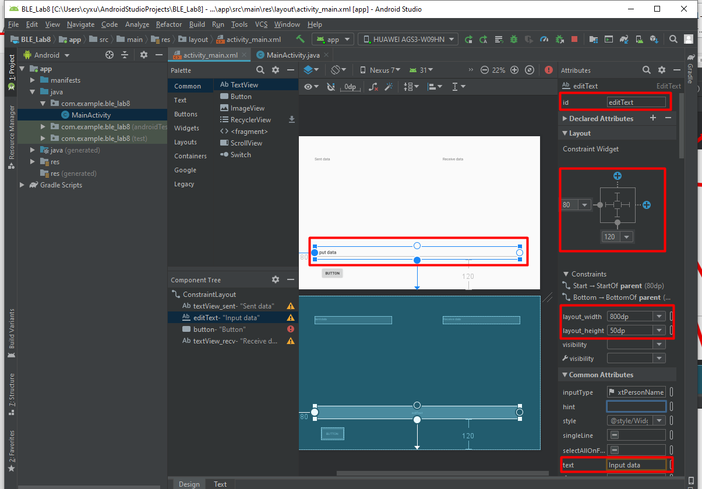

1. Add two buttons used for connecting Raspi and sending information. The properties are shown as below:

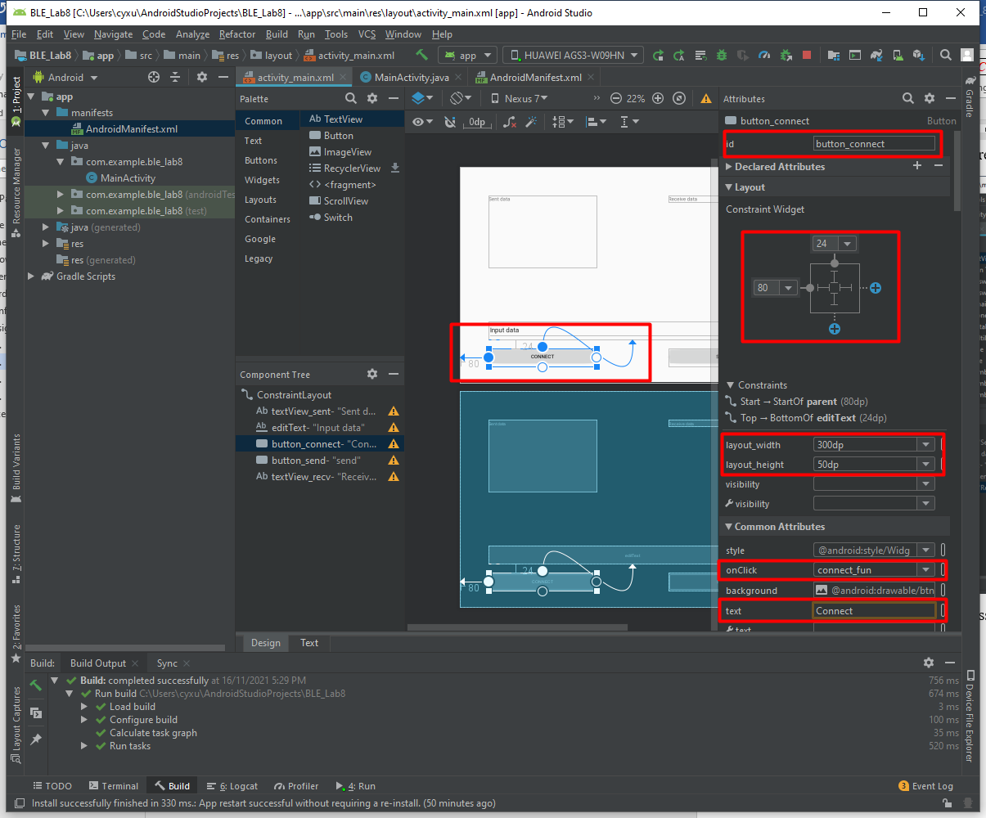

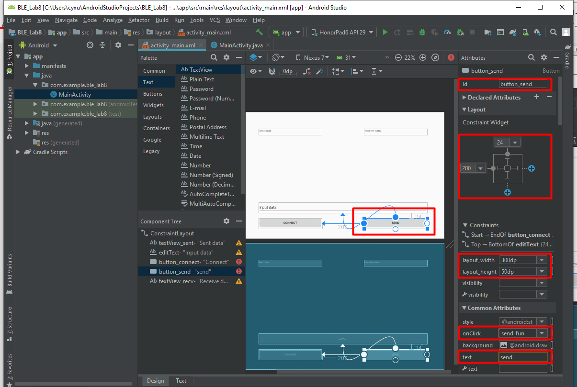

### Write Code

1. Add the bellowing code in AndroidManifest.xml file to enable the permissions correlated with Bluetooth.

<uses-permission android:name="android.permission.ACCESS_COARSE_LOCATION" />  
<uses-permission android:name="android.permission.ACCESS_FINE_LOCATION" />  
<uses-permission android:name="android.permission.INTERNET"/>  
<uses-permission android:name="android.permission.CHANGE_NETWORK_STATE"></uses-permission>  
<uses-permission android:name="android.permission.CHANGE_WIFI_STATE"></uses-permission>  
<uses-permission android:name="android.permission.ACCESS_NETWORK_STATE"></uses-permission>  
<uses-permission android:name="android.permission.ACCESS_WIFI_STATE"></uses-permission>  
<uses-permission android:name="android.permission.CHANGE_WIFI_MULTICAST_STATE" />  
<uses-permission android:name="android.permission.INTERNET" />

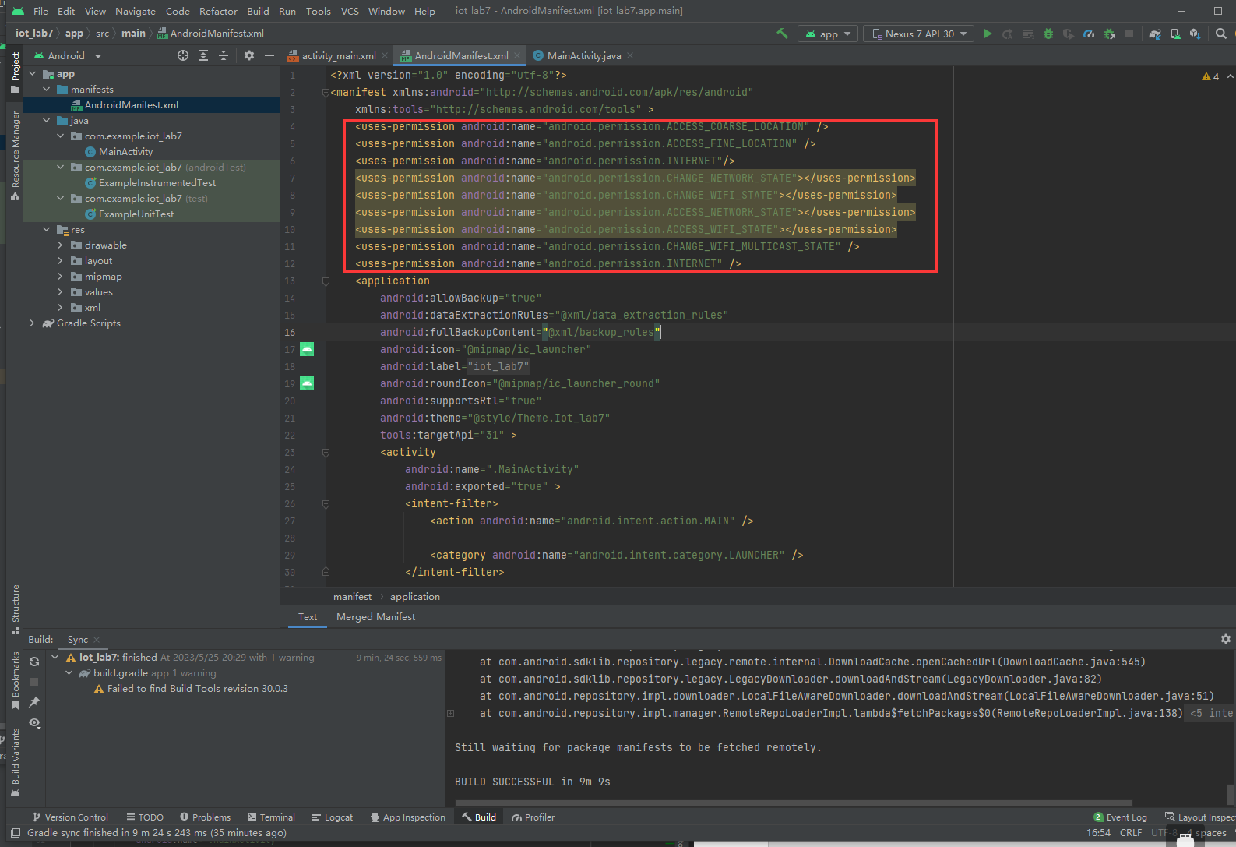

1. Open MainActivity.java file and add the following packages.

import android.annotation.SuppressLint;  
import android.os.Bundle;  
import android.text.method.ScrollingMovementMethod;  
import android.widget.EditText;  
import android.widget.TextView;  
import android.util.Log;  
import android.os.Handler;  
import android.os.Message;  
import java.net.DatagramPacket;  
import java.net.DatagramSocket;  
import java.net.InetAddress;  
import android.view.View;

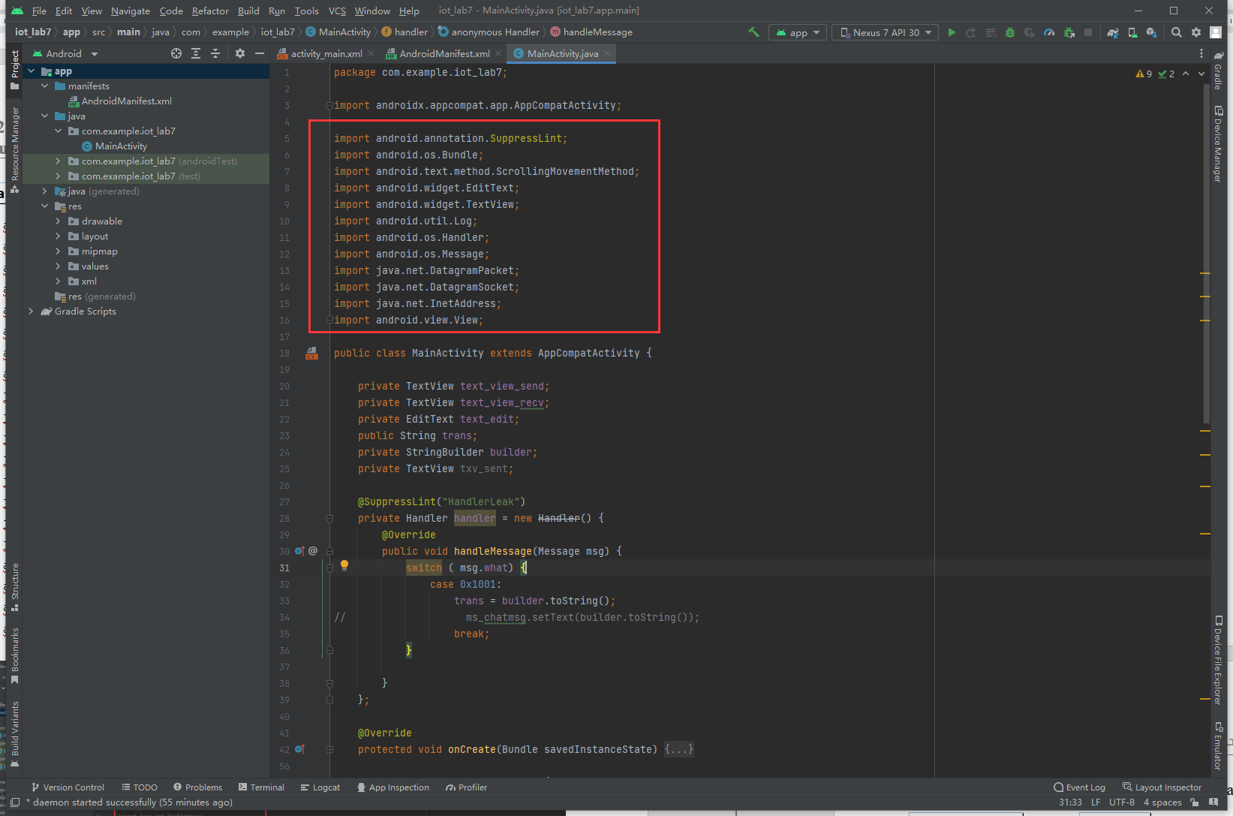

1. Create text_view_send, text_view_recv and text_edit classes for textView_sent , textView_recv and editText, respectively. Also create the handler as follows.

All the classes and variables must be created in the MainActivity class.

private TextView text_view_send;  
 private TextView text_view_recv;  
 private EditText text_edit;  
 public String trans;  
 private StringBuilder builder;  
 private TextView txv_sent;

@SuppressLint("HandlerLeak")  
 private Handler handler = new Handler() {  
 @Override  
 public void handleMessage(Message msg) {  
 switch ( msg.what) {  
 case 0x1001:  
 trans = builder.toString();  
 break;}  
 }  
 };

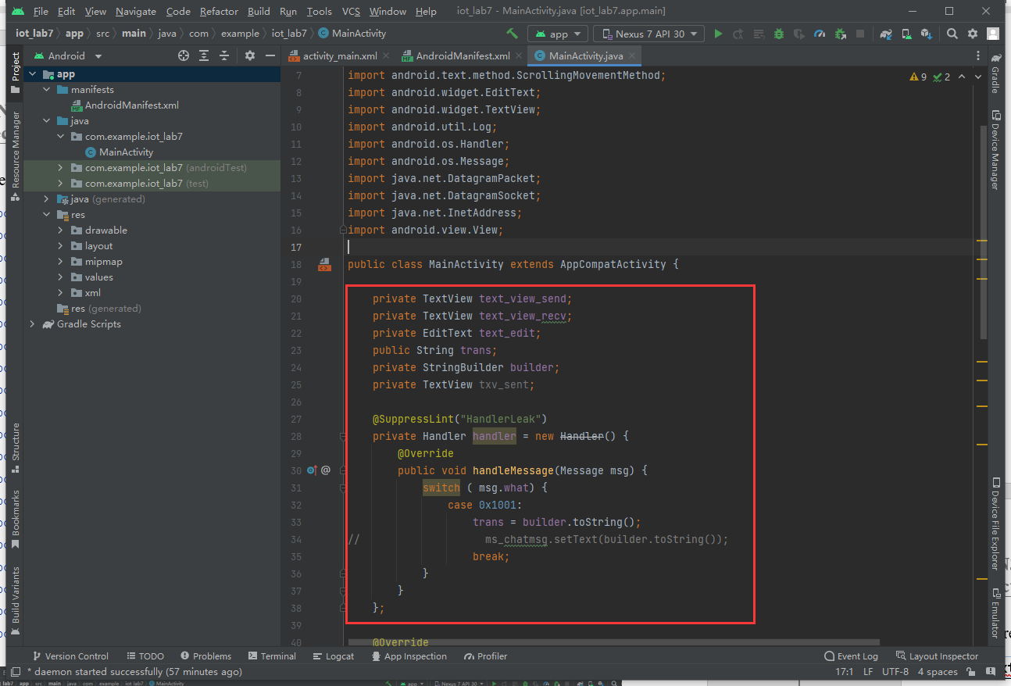

1. Correlate text_view_send, text_view_recv and text_edit with textView_sent , textView_recv , builder and editText, respectively. And enable the textView_sent enroll.

The bellowing codes should be written in the onCreate() method. The onCreate() is the initialize method of MainActivity class and it would be executed automatically.

builder = new StringBuilder();  
text_view_send = findViewById(R.id.*textView_sent*); // obtain the text_view by ID  
text_view_recv = findViewById(R.id.*textView_recv*); // obtain the text_view by ID  
text_edit = findViewById(R.id.*editText*); // obtain the text_edit by ID  
  
text_view_send.setMovementMethod(ScrollingMovementMethod.*getInstance*()); // Enable text_view_

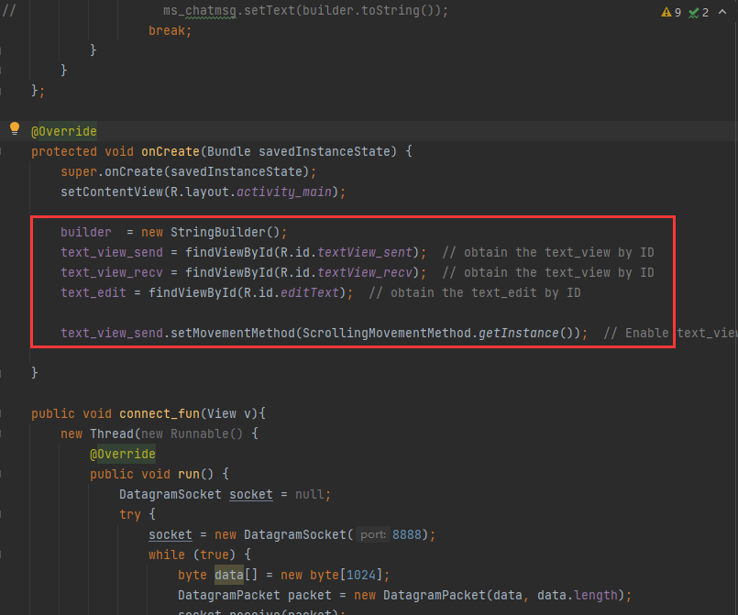

1. Write **connect_fun**(View v) function for “CONNECT” button. The function name must be the same with UI configuration.

All the functions must be created in the MainActivity class.

   public void connect_fun(View v){  
 new Thread(new Runnable() {  
 @Override  
 public void run() {  
 DatagramSocket socket = null;  
 try {  
 socket = new DatagramSocket(8888); //receive port number  
 while (true) {  
 byte data[] = new byte[1024];  
 DatagramPacket packet = new DatagramPacket(data, data.length);  
 socket.receive(packet);  
 final String result = new String(packet.getData(), packet.getOffset(), packet.getLength());  
 Log.*i*("get result:", result);  
  
 runOnUiThread(new Runnable() {  
 @Override  
 public void run() {  
 text_view_recv.setText(result);  
 }  
  
 });  
 }  
 } catch (Exception e) {  
 e.printStackTrace();  
 }  
 }  
 }).start();  
}

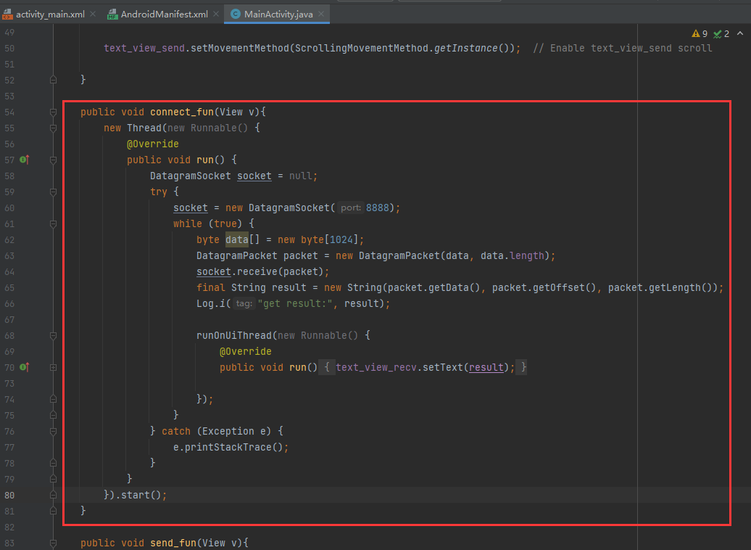

1. Write **send_fun()** function for “SEND” button.

We define a **chat([String])** function used to send the messages. Besides, remember to **put your corresponding IP address number** in InetAddress.getByName(“”).

   public void send_fun(View v){  
 String str = String.*valueOf*(text_edit.getText());  
 if (!str.isEmpty()) {  
 chat(str);  
 text_view_send.setText(str);  
 }  
}

     public void chat(String str) {  
 new Thread(new Runnable() {  
 public void run() {  
 try {  
  
 InetAddress address = InetAddress.*getByName*("192.168.43.126"); // Raspberry pi  
 int port = 8003;  
 byte[] data_se = str.getBytes();  
 handler.sendEmptyMessage(0x1001);  
 DatagramPacket packet = new DatagramPacket(data_se, data_se.length, address, port);  
 DatagramSocket socket = new DatagramSocket();  
 socket.send(packet);  
  
 byte[] data2 = new byte[1024];  
 DatagramPacket packet2 = new DatagramPacket(data2, data2.length);  
 socket.receive(packet2);  
 handler.sendEmptyMessage(0x1001);  
  
 socket.close();  
 } catch (Exception e )  
 {  
 e.printStackTrace();  
 }  
 }  
 }).start();  
}

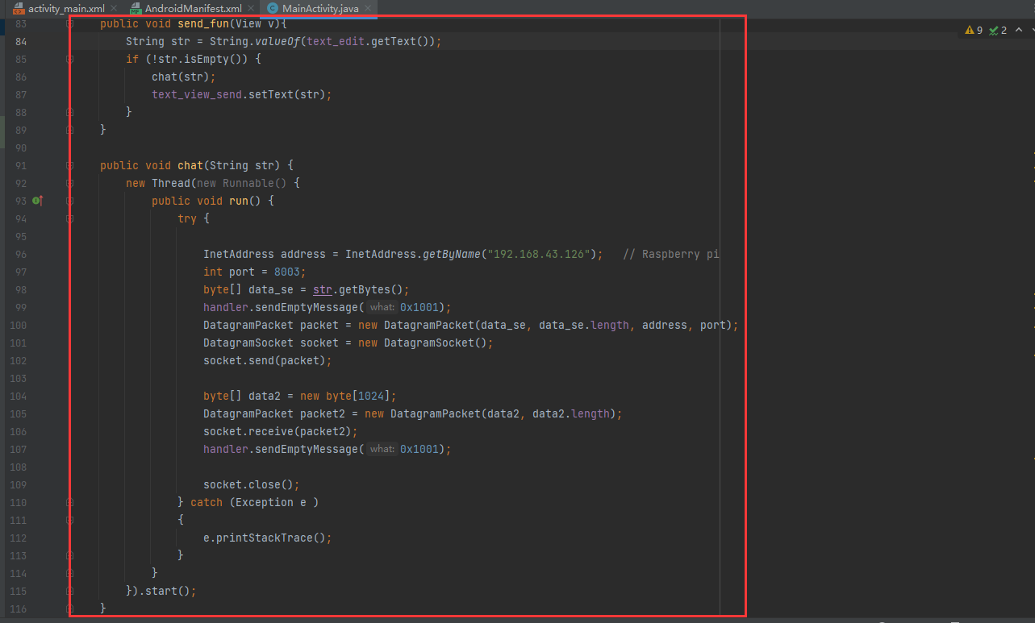

1. Click the button as below to test your application on Pad.

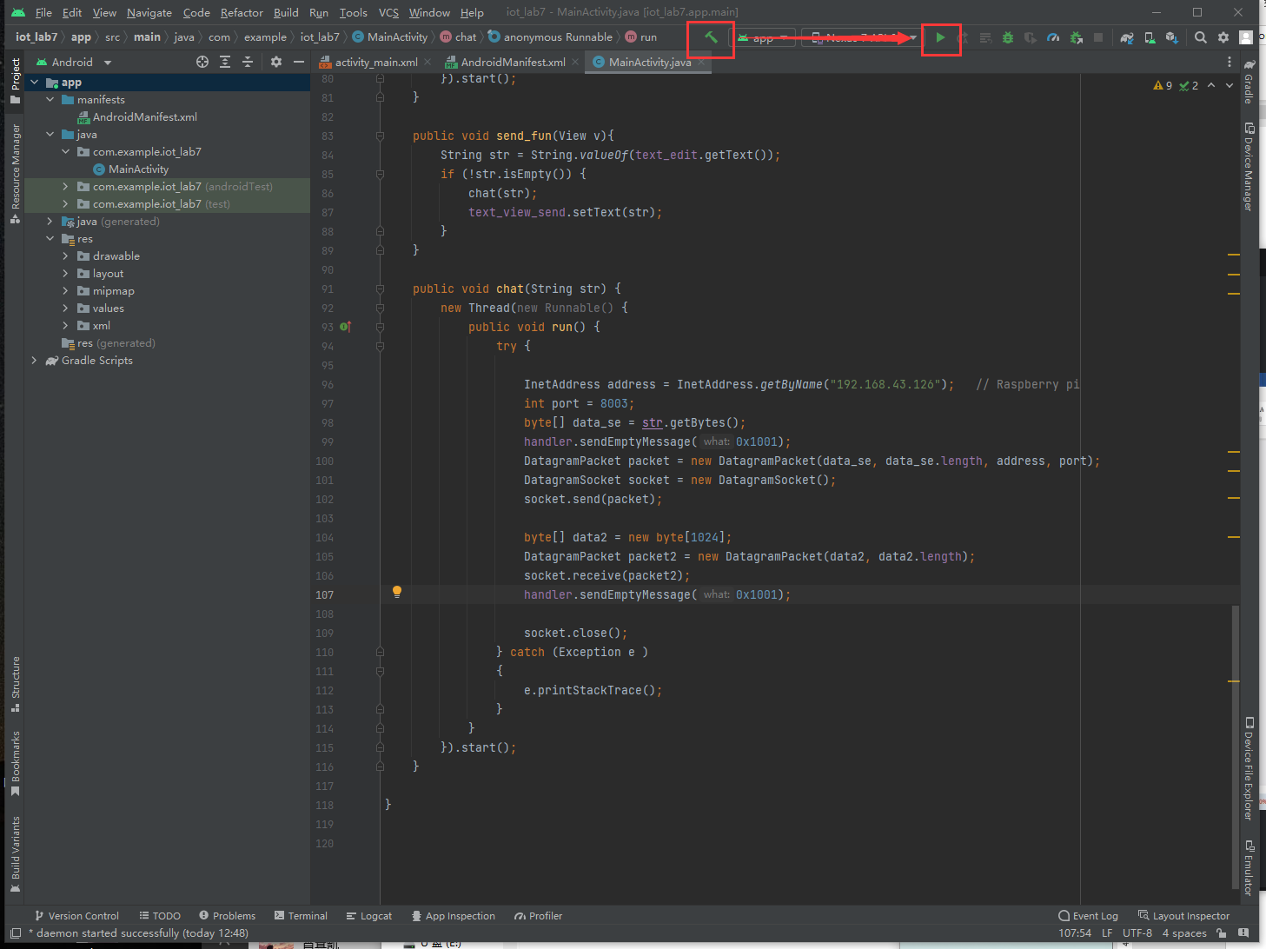

### Method of usage

1. If you want to send your messages to the Raspi, simply use the **chat()** function. Remember that it takes one argument in the form of [String]. For example, if you want to send “Wednesday” , your code should be：chat(“Wednesday”);
2. If you want to further process the received message from the pad, you can add your own code in the **run()** function inside **connect_fun()**. The received value is named result and is in the form of [String].

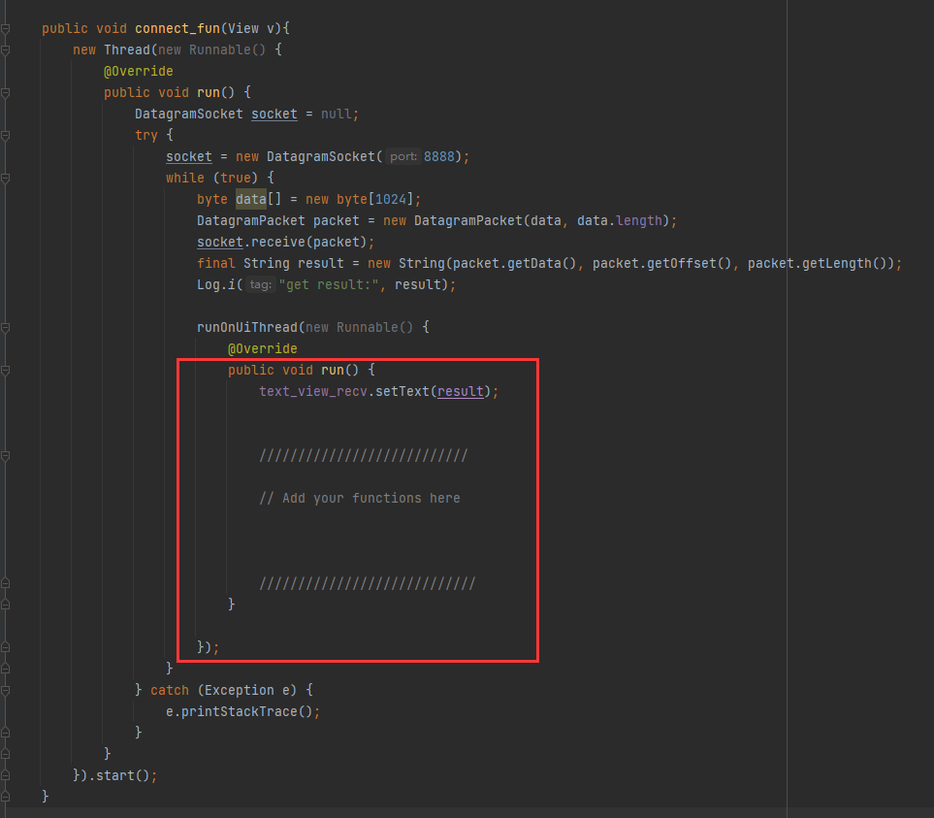

Notice

* Replace the IP address in **chat([String])** with the IP address of your Raspi.
* Remember to check the receive / send port number.

Port 8003 in chat() meaning that the pad will send the message to the 8003 port of Raspi.

Port 8888 in connect_fun() meaning that the pad will try to obtain messages sent to its 8888 port.

* Remember to check if Pad and Raspi are under the same WLAN**.**
* Remember to click connect button before sending any messages.

### Generate Signed Installation Package (FYI)

To install our application into other android device, we should generate the installation package (APK).

1. Click Build -> Generate Signed Bundle/APK

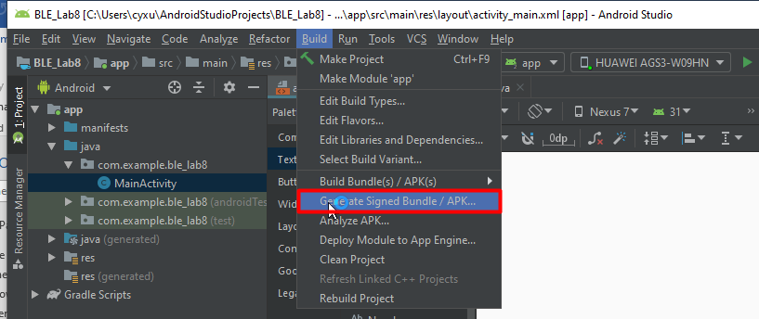

1. Select APK and click Next.

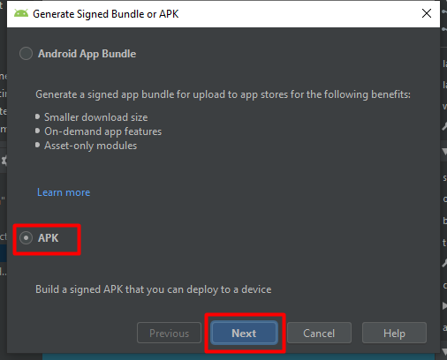

1. Click Create new to create a KEY file.

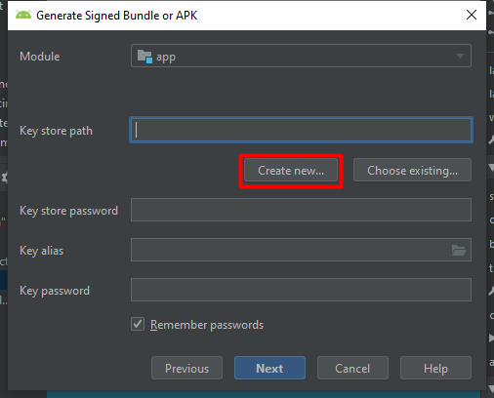

1. Select a folder used to store the KEY file and give the KEY file a name, e.g. BLE_lab8, and click OK.

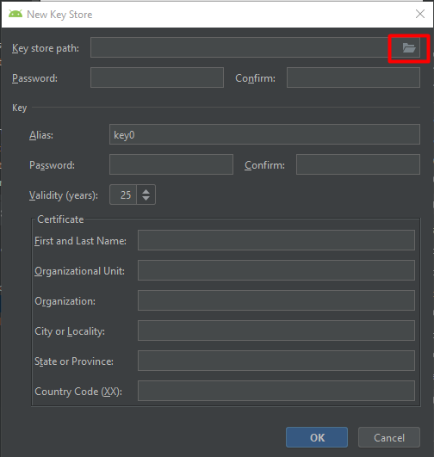

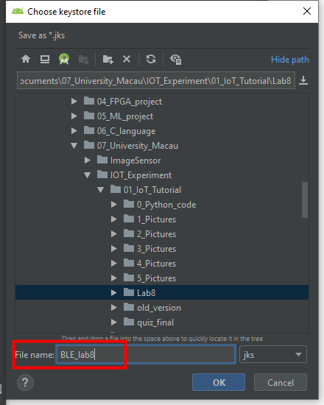

1. Create the Passwords, and input at least one Certificate issuer field. Then click OK.

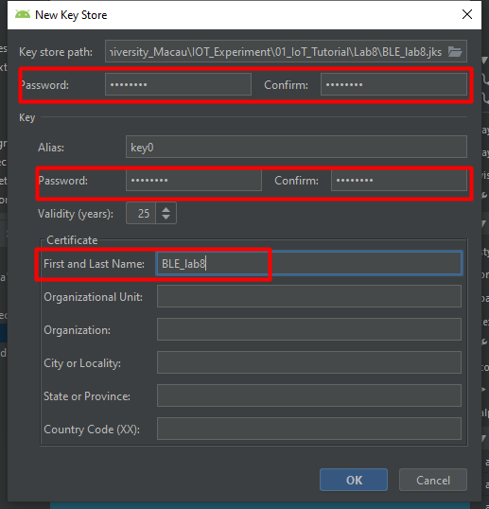

1. Click Next.

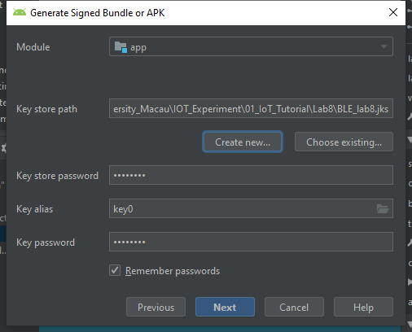

1. Select the Destination Folder used to store the generated APK. And further select release and V2 (Full APK signature) and finally click Finish. The project should be built and the Signed Installation Package .apk file is generated and saved in the release folder shown as below.

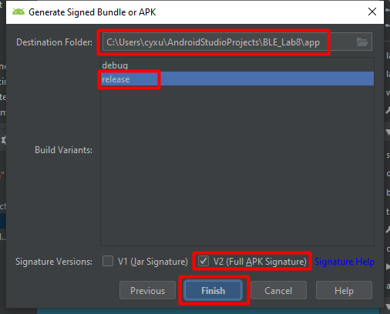

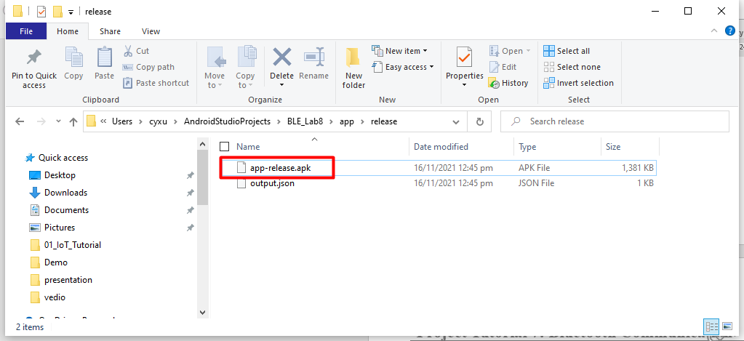

## Write Python Code

1. Create a new python file and give it a name.

The python file should be in the same folder as lcd1602.py and socket_receive.py

1. Write the following code to receive the messages sent by Android application.

from lcd1602 import *

from socket_receive import socketReceive

lcd = lcd1602(1, 0x27) #set address for lcd

lcd.show_string(1,0,'WLAN Test') #initial display

def receive_and_display():

    while True:

        received_data = socketReceive()

        if received_data:

            print(received_data)

            lcd.clear_screen() #clear information before display

            lcd.show_string(1, 0, received_data)

receive_and_display()

1. **Keep your Android application well connected with AP,** and then run the python code. The python code will wait to receive message. If we send a message to Raspi using Android application, Raspi should display the received message on LCD1602, without replying to Android.

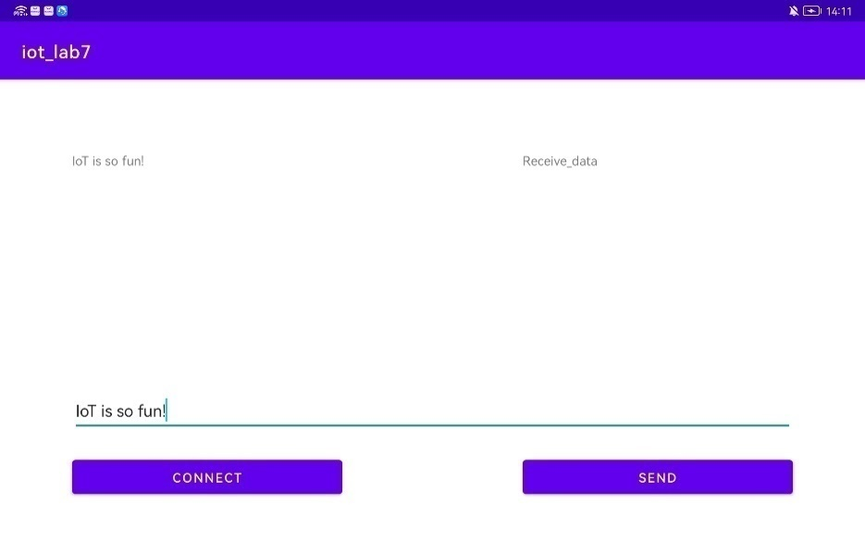

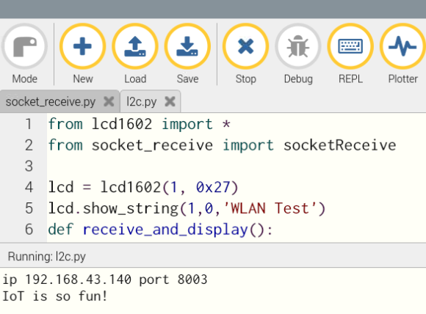

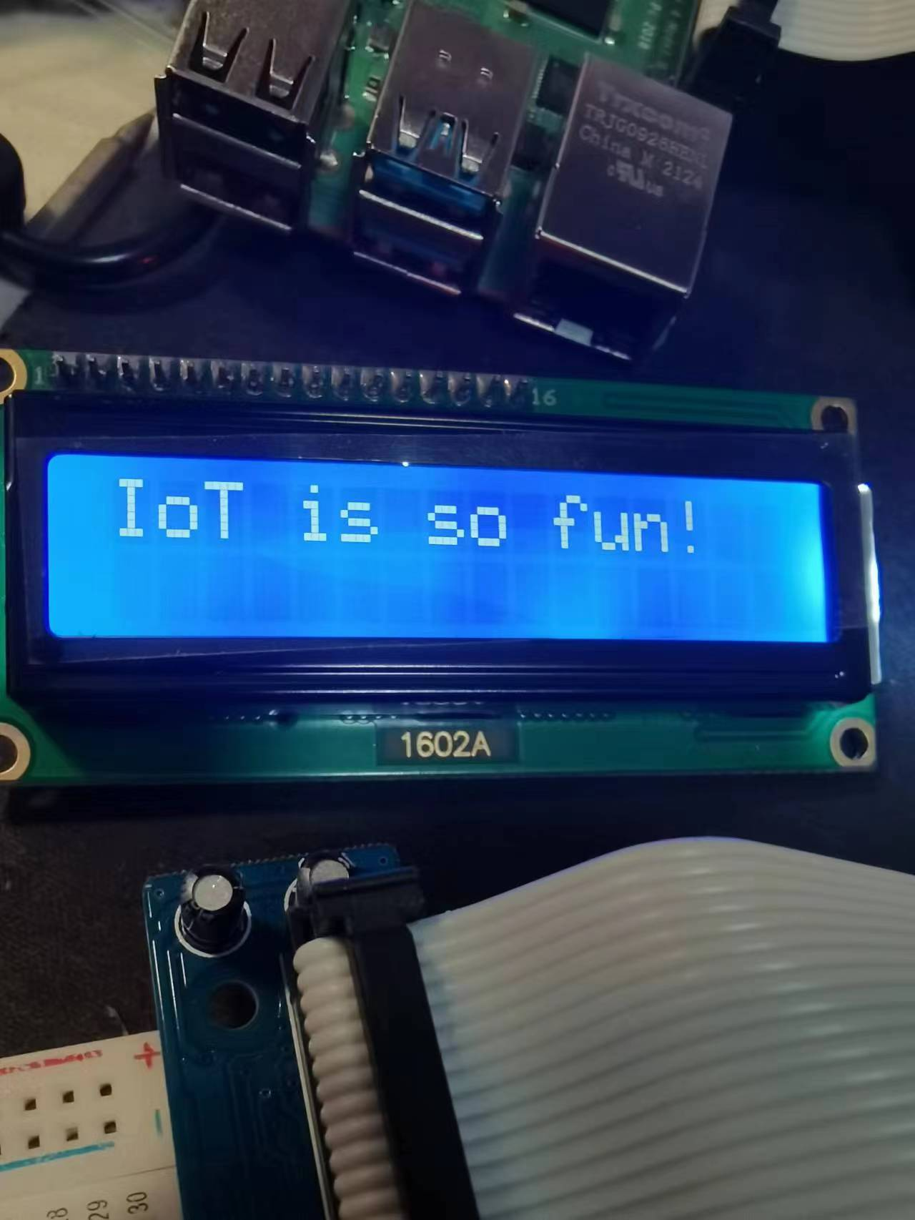

# Expansion

By now, for Pad user, they do not know whether Raspi has received message or not at Pad end. Thus, we want you to realize the below two targets about the “User Interaction”:

1. **When Raspi receive the message from Pad, it can immediately reply to Pad.**
2. **With Pad first transferring data and receiving reply from Raspi, the pad pop up “Connected”.**

**Tips:** Notice that, in both socket_transfer.py and socket_ receive.py, we have created a socket. But now, we need add another socket for improving the user interaction (UDP is one-way protocol):

s1 = socket.socket(socket.AF_INET, socket.SOCK_DGRAM)#socket for receive

s2 = socket.socket(socket.AF_INET, socket.SOCK_DGRAM)#socket for transfer

raspi_ip = “192.168.43.140”#set raspi ip

pad_ip = “192.168.43.72”#set Pad ip

And we use the function below to receive and transfer the message:

data, addrR = s1.recvfrom(128)#UDP receive

addrT = (pad_ip, 8888)#ip,port

s2.sendto(data, addrT)#UDP transfer

s2.close()

One way to realize the notification on the pad is to use the toast method:

Toast.makeText(getApplicationContext(), “Connected”, Toast.LENGTH_SHORT).show();

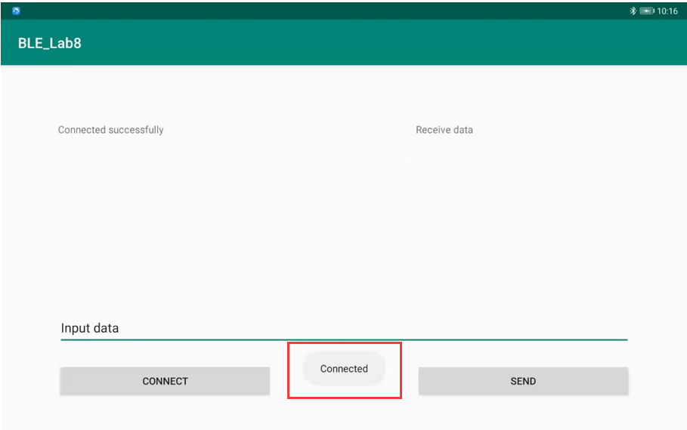

# Reference

1. 安卓 socket 的基本使用, <https://blog.csdn.net/lfq88/article/details/118028400>
2. Python3 Socket网络编程, <https://www.runoob.com/python3/python3-socket.html>
3. Android Studio中文社区, <http://forum.android-studio.org/forum.php>
4. Java 教程, <https://www.runoob.com/java/java-tutorial.html>

# End of Tutorial 8

# Answer for Expansion:

import socket

from time import sleep

s1 = socket.socket(socket.AF_INET, socket.SOCK_DGRAM)#socket for receive

s2 = socket.socket(socket.AF_INET, socket.SOCK_DGRAM)#socket for transfer

raspi_ip = "192.168.43.140"#set raspi ip

pad_ip = "192.168.43.72"#set Pad ip

s1.settimeout(0.01)

s1.bind((raspi_ip, 8003)) #raspi ip and port

s2.settimeout(1)

print("receive: raspi ip", raspi_ip, "port", 8003)

print("send: pad ip", pad_ip, "port", 8888)

def socketReceive():

    while True:

        try:

            data, addrR = s1.recvfrom(128)#UDP receive

            addrT = (pad_ip, 8888)#ip,port

            print("data",data)

            datastr=data.decode(encoding='UTF-8')

            if data:

                print('hello')

                s2.sendto(data, addrT)#UDP transfer

                s2.close()

                return datastr

        except:

            return False

if __name__ == '__main__':

    i=1

    while True:

        re = socketReceive()

        if re:

            print('recieved data:', re)